**Optimized Diagnostic System**

**Team Name:** Fail0verflow

**Problem**

It is necessary to have a database system with QR access that allows the administration, management and updating of the diagnoses and clinical records of patients who are treated in a medical institution, to avoid the very common diagnostic errors and confusion with them, which often end up in irreparable damage to patients.

**Overview**

In the medical scenario in every hospital it is necessary to keep a correct record and order at the moment of diagnosing the different patients that come to this institution in order to provide a correct attention according to their individual requirements.

Similarly, the medical record is considered the most important medical document for patients, this document should be prepared by all members of the medical team, its content comes mainly from the medical practice.

From the clinical history should arise the evolution of the disease and the conduct of the entire health team.

The clinical history can be defined as the instrument through which the physician elaborates the diagnosis, bases it and records the treatment and evolution of the patient.

**Background**

The current situation of the health system requires rational and effective management. It is one of the most important socioeconomic activities, which generates sensitivity in our society, with a tendency to continue increasing. The technological innovations, the greater life expectancy, the level of information of the society as a whole and therefore the greater demand justify the elaboration of systems with a high degree of efficiency and effectiveness. A fundamental tool is the management of information that can support decision making.

"Medicine is not an exact science" (La medicina no es una ciencia exacta - Dr. Silvia Cabrera, n. d. ), being aware that medicine, unlike mathematics, is not exact, it can be considered a margin of error in the diagnosis and treatment of the patient, that can be considered medical malpractice, however there is no specific study that determines how many are the inadequate treatments for a patient with severe diagnoses, Likewise, there are no statistics on how many of these diagnoses are correct or not. "A patient with chronic headache, for example, a doctor might consider all the usual pathological causes, but not discover the fact that the patient was exposed to carbon monoxide" (99% of Doctors Need Diagnostic Help, s. f.).

Hospitals, as the main actors in the health system, generate a significant volume of information, but in most cases it is dispersed or not available in a timely manner.

An analysis conducted by Estadão has shown that between 2010 and 2014 the number of processes due to medical errors has grown 140%, and most of them have resulted from errors in diagnostic reports. In the United States, a review of the medical literature has revealed that the incidence of deaths associated with errors is about 250,000 per year, which places human errors - even due to misinterpretation of reports and examinations - as the third leading cause of death in hospitals, behind only heart disease and cancer.

Research has shown that 99 percent of physicians make mistakes on a regular basis without realizing it at the time of diagnosis.

Today, medical errors have become an accepted, but unfortunate, part of the health sector. And sometimes, professionals have underestimated their contribution to the development of the problem.

Art Papier, a dermatologist and specialist in medical informatics, has commented that there is only one percent of doctors who do not make mistakes during diagnosis and care of patients, being exceptional cases. However, most of the oversights committed have not put the patient's life at risk.

"Ninety-nine percent regularly make mistakes that they never realize they made; we really don't know how many mistakes we are making," the specialist says.

Examples of these mistakes are the application of medications by routes for which they have not been designed, errors in blood transfusions or obtaining X-rays, or in more dramatic cases, mistakes when indicating which limb should be amputated or which side of the brain should be subjected to surgery.

According to the WHO, errors related to wrongly prescribed medications alone cost health systems around the world some $42 billion (37 billion euros).

The figures provided by the WHO refer only to low- and middle-income countries (where 80 percent of the global population lives), so the actual number could be even higher, taking into account that also in developed countries one in 10 patients is a victim of health care failures

**Various factors lead to such errors:**

The new pathologies and chronic diseases. The appearance of new diseases for modern medicine leads to errors in diagnosis.

Change in the level of demand of patients. The increase in the standard of living and the training of people, lead to a greater demand and concentration on the services provided.

**Most Common Diagnostic Errors**

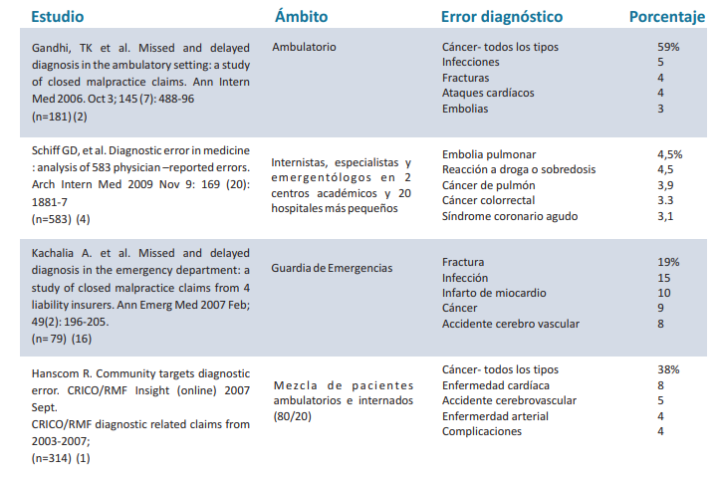

**Benefits of an improved digital system:**

* Give you the ability to update that information
* Manage knowledge, when the information has been understood and is applied later in action.
* Given that information leads to being able to "do better", it is also to be expected that there will be a benefit in terms of budgetary efficiency.
* Improve clinical practice (decision support).

**Bibliography**

* Hospital Information Systems-Articles-IntraMed (undated). Retrieved December 7, 2020, from https://www.intramed.net/contenidover.asp?contenidoid=44061
* MV. (undated). MV - Medical reports and diagnostics: Main mistakes made and how to avoid them. Retrieved December 7, 2020, from https://mv.com.br/es/blog/informes-medicos-y-diagnosticos--principales-errores-cometidos-y-como-evitarlos
* Only 1% of doctors do not make mistakes in the diagnosis of the patient. (undated). Retrieved December 7, 2020, from https://www.edicionmedica.ec/secciones/profesionales/s-lo-el-1--de-m-dicos-no-comete-errores-en-el-diagn-stico--92770
* Gonzalez, A. V. (undated). Medical malpractice in Ecuador. 151.
* 99% of Doctors Need Diagnostic Help. (undated). Medscape. Retrieved December 7, 2020, from http://www.medscape.com/viewarticle/899719